**Assignment 16.6**

**Problem Statement:**

Write a map reduce program to join the below given two datasets using Reducer side join. You can download the datasets from the below link :

<https://drive.google.com/open?id=0ByJLBTmJojjzSWhfXzI5NGh4RGM>

Dataset description of dataset1.csv is as follows: id,first_name,last_name,email,gender,ip_address

Dataset description of tdataset2.csv is as follows: id,first_name,last_name

**Program:**

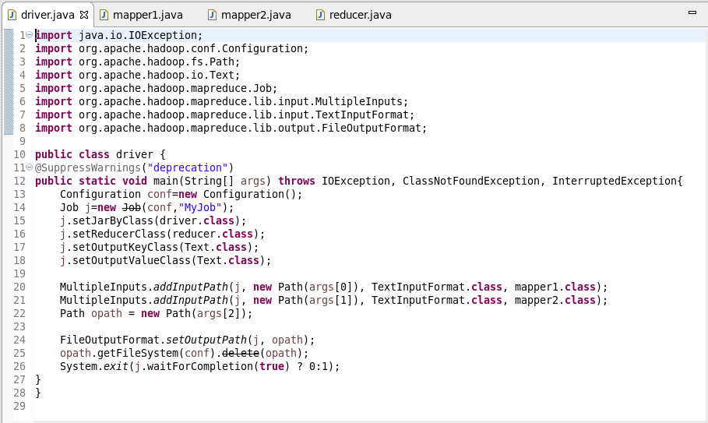

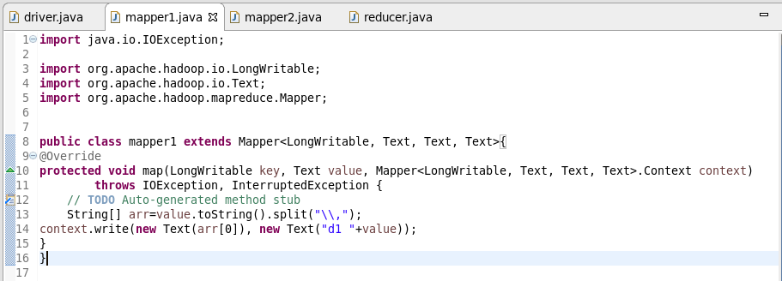

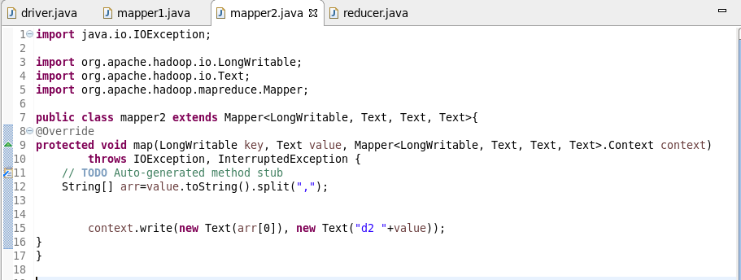

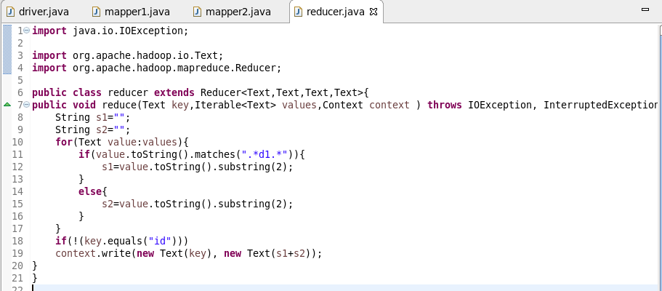

**Output:**

The records from dataset1.csv and dataset2.csv are joined using common field in both the datasets which is id.

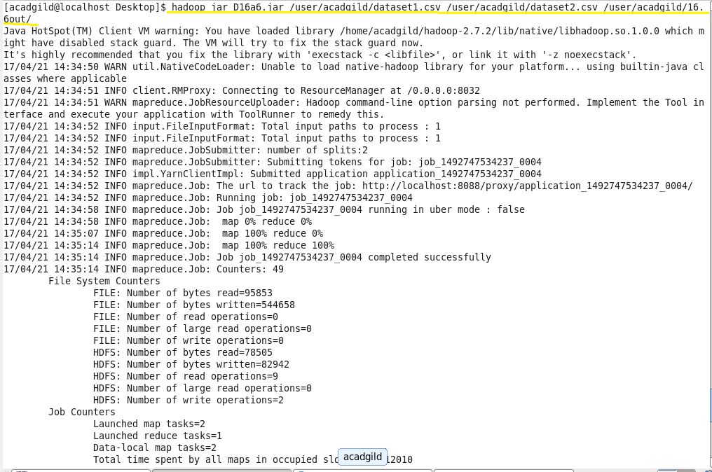

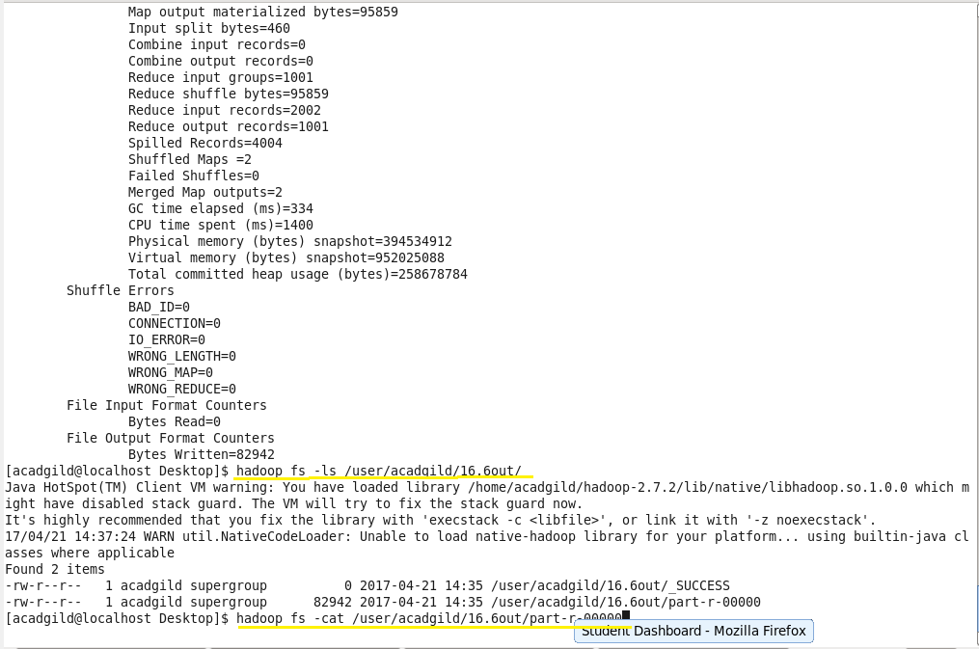

As the output consists of large number of records screenshot of last few records is attached below:

